Quantum Policy Gradient and Value-Based Quantum Reinforcement Learning

1. Problem
Reinforcement Learning (RL) algorithms can be broadly divided into policy-based methods (which directly optimize the policy) and value-based methods (which learn value functions such as Q-values).
Classical methods like Policy Gradient, Actor–Critic, and Q-Learning are powerful but can struggle with high-dimensional state spaces and exploration.
Quantum Reinforcement Learning (QRL) proposals explore whether quantum circuits can represent policies or value functions more efficiently, potentially improving learning dynamics or expressivity.

2. Intuition
Quantum policy gradient and value-based QRL follow the same learning loop as classical RL but replace function approximators with parameterized quantum circuits (PQCs):
- A quantum circuit represents a policy or a value function
- Measurements provide action probabilities or value estimates
- Classical optimizers update circuit parameters
Quantum superposition allows simultaneous evaluation of multiple action components, while entanglement can encode complex correlations.

3. Algorithm / Circuit Structure

(A) Quantum Policy Gradient (Actor)
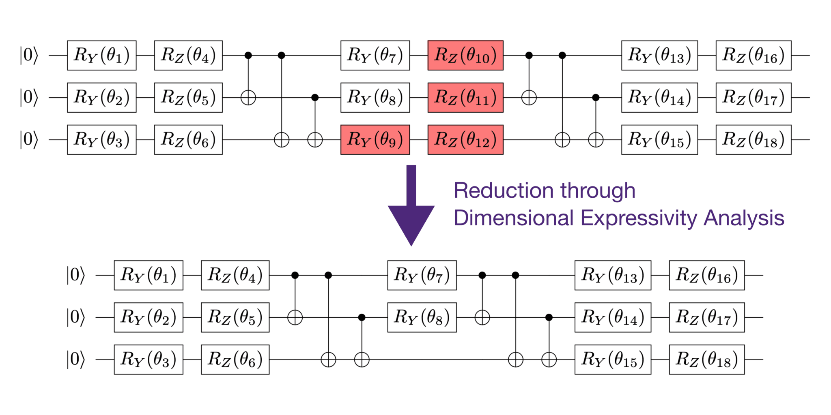
- Encode state (|s)
- Apply quantum policy circuit (U())
- Measure to obtain action probabilities
- Update parameters using policy gradient

(B) Quantum Value-Based Methods (Critic / Q-Network)
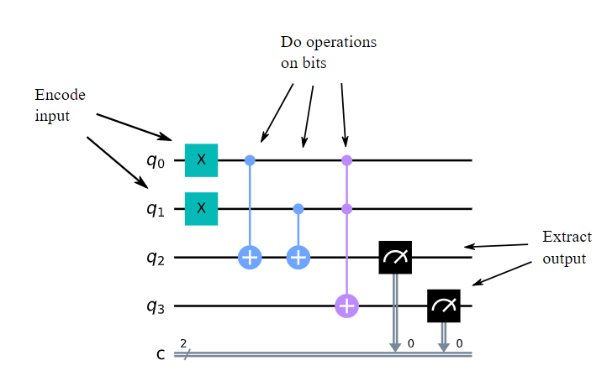
- Encode state–action pair (|s,a)
- Apply quantum value circuit (V())
- Measure expectation value as (Q(s,a))
- Update parameters via temporal-difference learning

4. Simple Math Involved

Quantum Policy Gradient
[ _J() = [(a|s) G_t] ]

Quantum Value-Based Learning
[ Q(s,a) = (s,a,) | O | (s,a,) ]
[ L = (r + _a Q(s’,a) - Q(s,a))^2 ]

5. Python Code (Quantum Policy Gradient & Value-Based QRL)
import numpy as np
from qiskit import QuantumCircuit
from qiskit.circuit.library import RealAmplitudes
from qiskit.primitives import Sampler, Estimator
num_qubits = 2
policy_ansatz = RealAmplitudes(num_qubits, reps=2)
policy_circuit = QuantumCircuit(num_qubits)
policy_circuit.compose(policy_ansatz, inplace=True)
policy_circuit.measure_all()
sampler = Sampler()
policy_result = sampler.run(policy_circuit, shots=512).result()
action_probs = policy_result.quasi_dists[0]
print("Policy (action probabilities):", action_probs)
value_ansatz = RealAmplitudes(num_qubits, reps=2)
value_circuit = QuantumCircuit(num_qubits)
value_circuit.compose(value_ansatz, inplace=True)
estimator = Estimator()
observable = [["ZI", 1.0]]
value = estimator.run(value_circuit, observable).result().values[0]
print("Estimated Q-value:", value)

6. Where the Algorithm Is Useful
- Decision-making problems
- Control systems
- Quantum-enhanced RL research
- Hybrid quantum–classical agents

7. Limitations
- Mostly theoretical proposals
- Training instability
- Noise sensitivity
- No demonstrated quantum advantage yet

8. Comparison with Classical Policy Gradient & Q-Learning
- Function approximator: Neural networks vs. quantum circuits
- Optimization: Backpropagation vs. hybrid quantum–classical
- Exploration: Classical randomness vs. quantum measurement
- Maturity: Classical methods are mature; quantum methods are experimental

9. One-Sentence Summary
Quantum policy gradient and value-based QRL use quantum circuits as policies or value functions within classical reinforcement learning frameworks.

